# Tutorial 1: Demand Forecasting

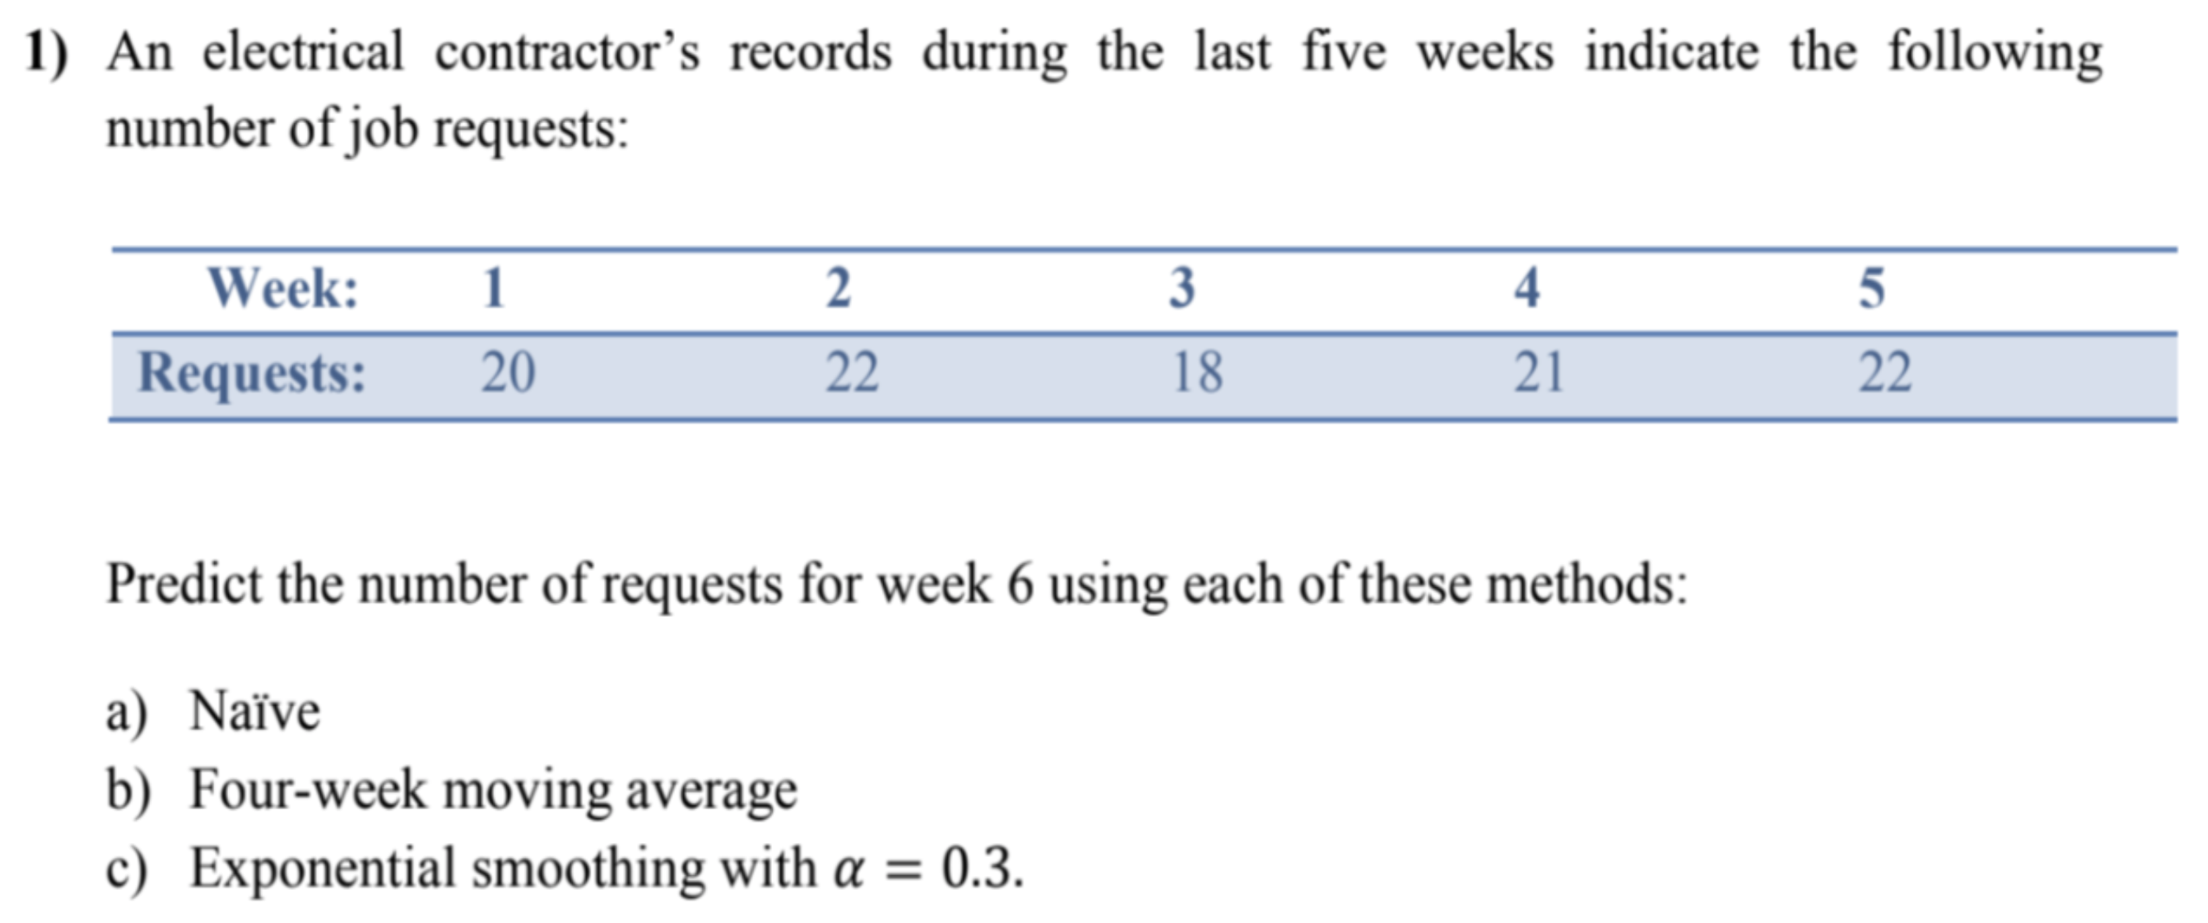

$22$

$\frac{22+18+21+22}{4}=20.75$

$F_{t}=F_{t-1}+α\left(A_{t-1}-F_{t-1}\right)$ $$F_{1}=20 \\ F_{2}=20+0.3\left(20-20\right)=20 \\ F_{3}=20+0.3\left(22-20\right)=20.6 \\ F_{4}=20.6+0.3\left(18-20.6\right)=19.82 \\ F_{5}=19.82+0.3\left(21-19.82\right)=20.17 \\ F_{6}=20.17+0.3\left(22-20.17\right)=20.72$$

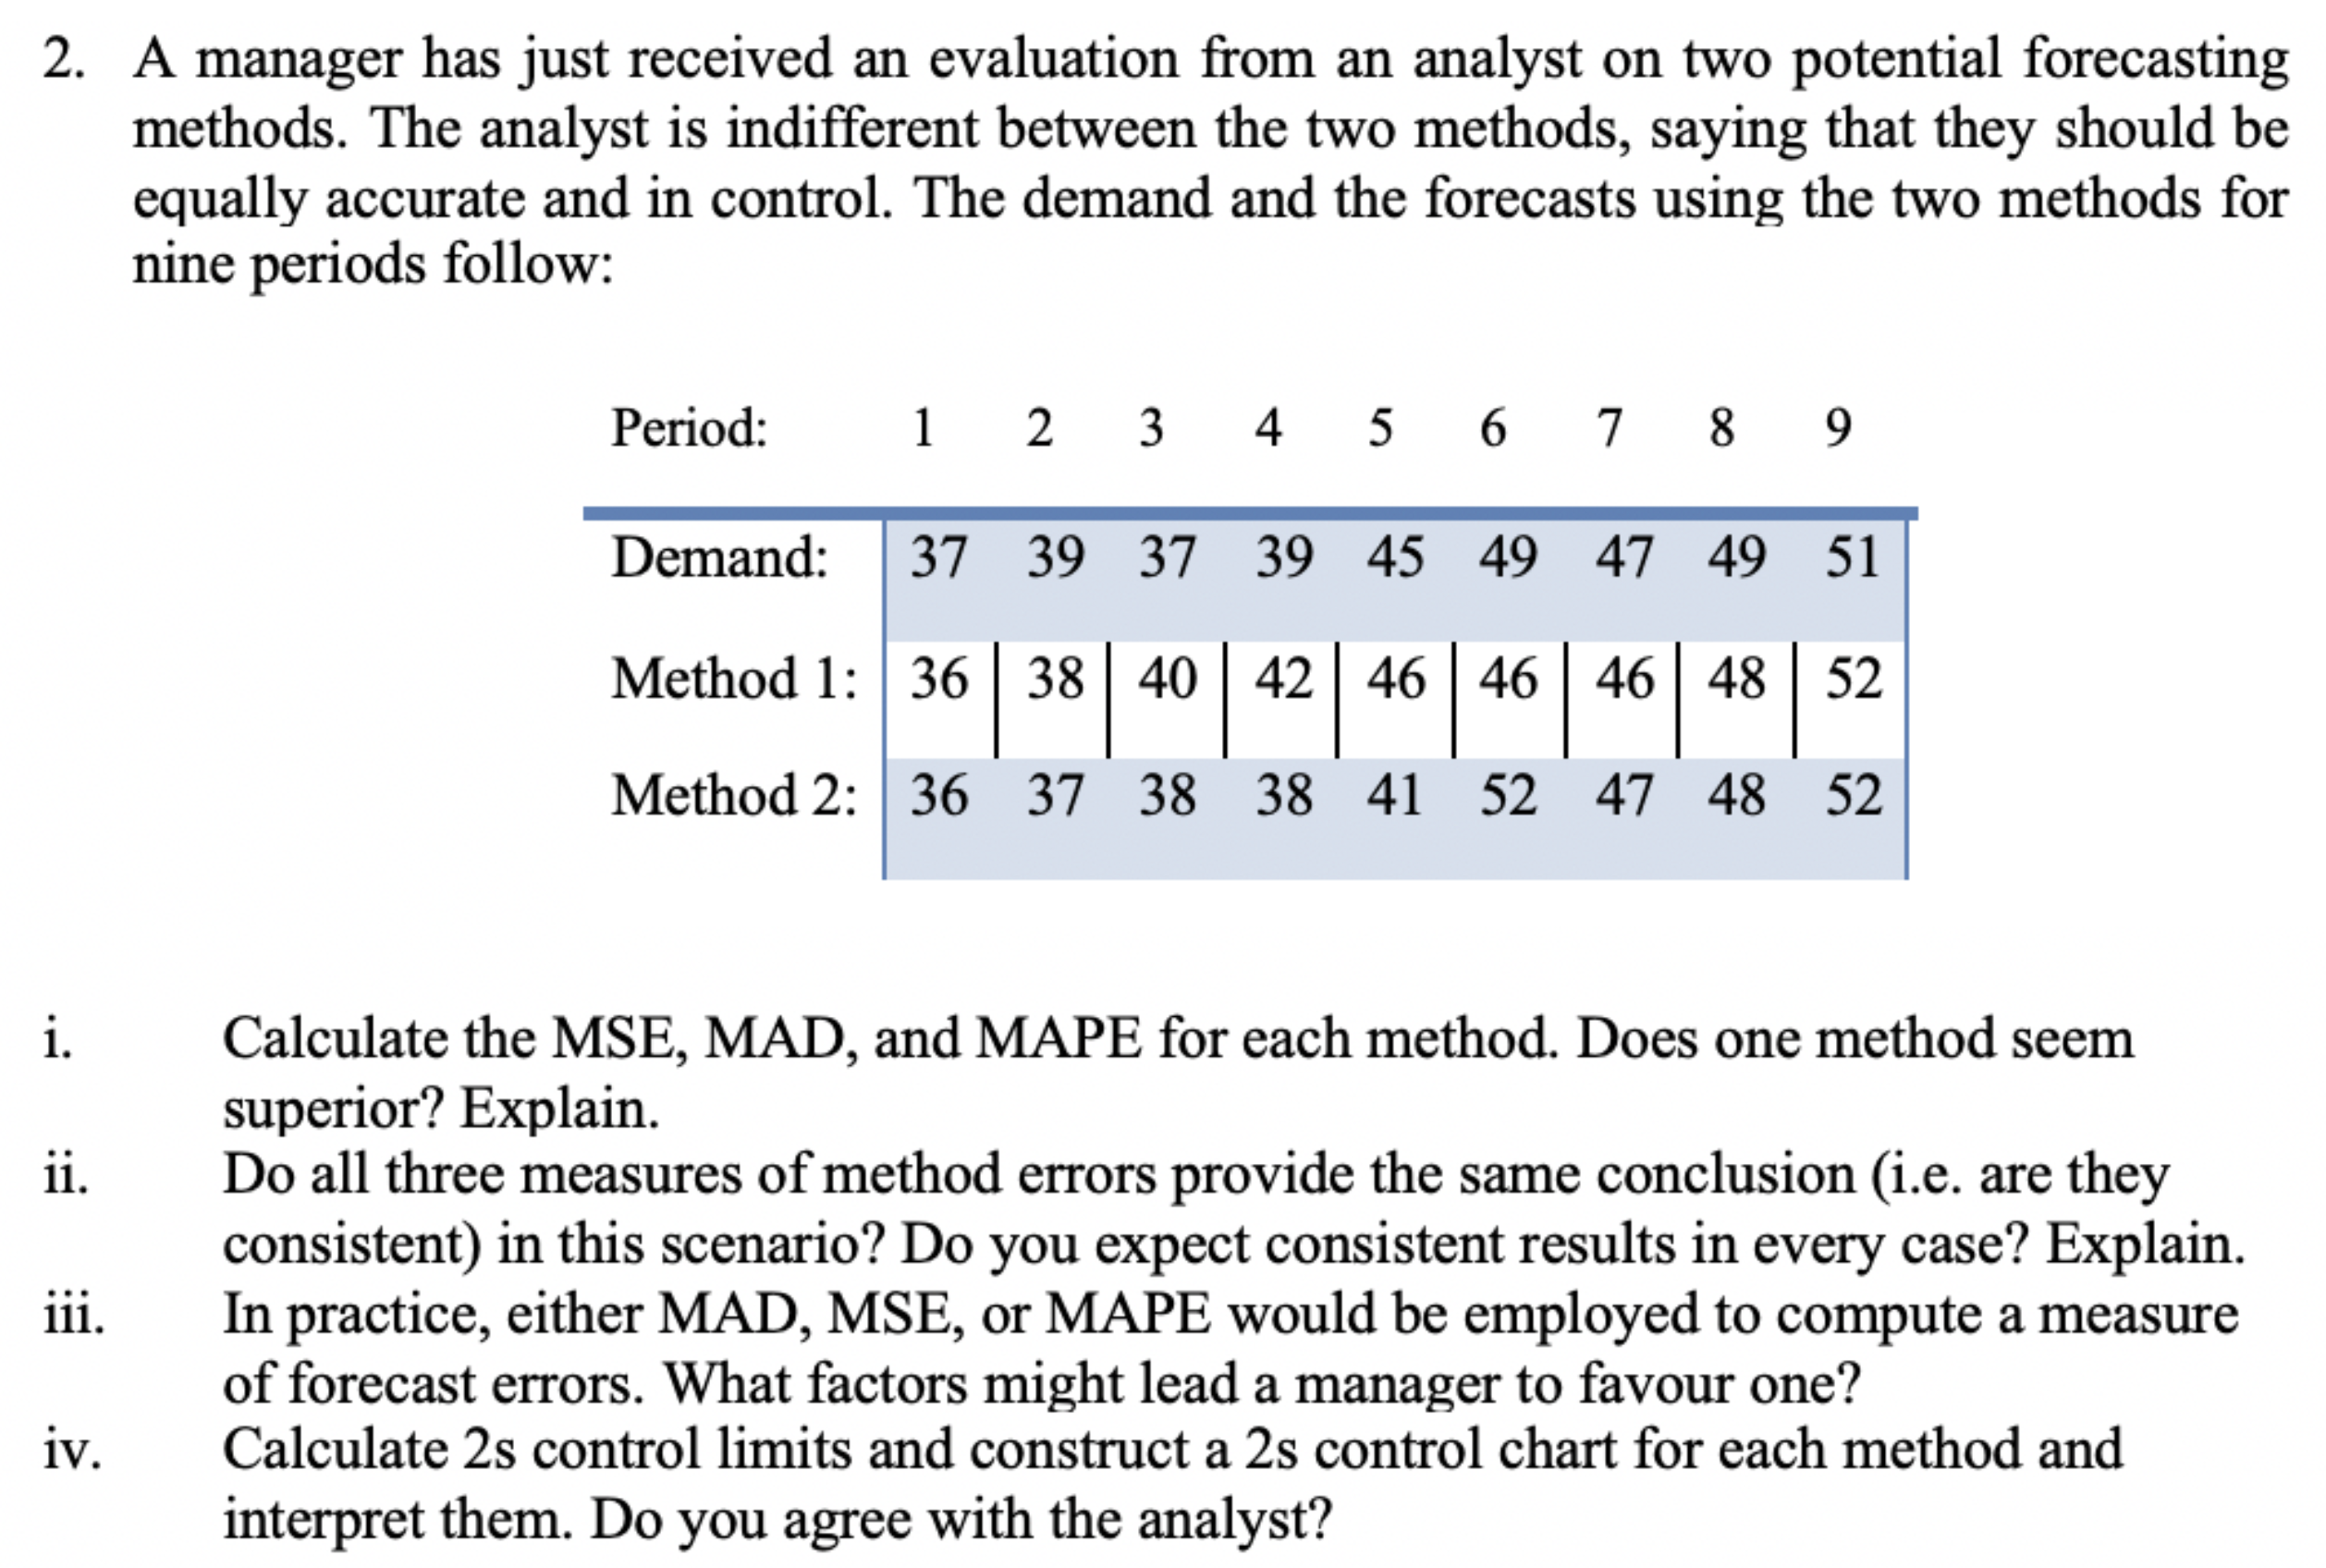

$MSE=\frac{∑{\left(A_{i}-F_{i}\right)}^{2}}{n}, MAD=\frac{∑\left|e\right|}{n}, MAPE=\frac{∑\left[\frac{\left|A_{i}-F_{i}\right|}{A_{i}}×100\right]}{n}$

|  |  |  |  |
| --- | --- | --- | --- |
| **Method** | **MSE** | **MAD** | **MAPE** |
| $$1$$ | $$3.7$$ | $$1.7$$ | 4.0 |
| $$2$$ | $$3.8$$ | $$16$$ | $$3.6$$ |

Both methods have similar $MSE, MAD, MAPE$, so neither is superior.

1. In this case, all calculations are similar, but may not be the same in other cases.
2. $MSE$ is more sensitive to large forecast errors, $MAD$ is easy to calculate, $MAPE$ is easy to understand.

$s_{1}=\sqrt{MSE_{1}}=\sqrt{3.7}=1.92, s_{2}=\sqrt{MSE_{2}}=\sqrt{3.78}=1.95$

Method 1: $2s$ control limits: $0±2s_{1}=0±2\left(1.92\right)⇒0±3.8$

Method 1: $2s$ control limits: $0±2s_{2}=0±2\left(1.95\right)⇒0±3.9$

Similar $2s$ control limits, however some errors outside limits.

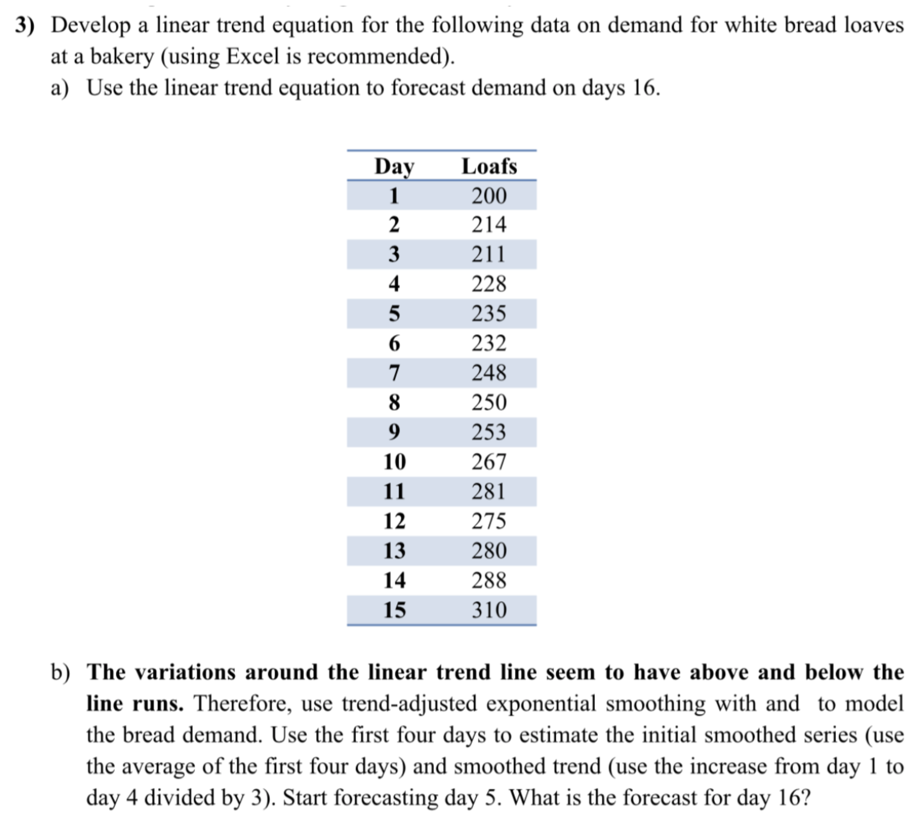

$α=0.3, β=0.2$

1. Equation of the trend: $y=7x+195.47$

$$D_{16}=7\left(16\right)+195.47⇒D_{16}=307.47$$

$S_{t}=TAF_{t}+α\left(A_{t}-TAF_{t}\right)$ $$T_{t}=T_{t-1}+β\left(S_{t}-S_{t-1}-T_{t-1}\right) \\ TAF_{t+1}=S_{t}+T_{t}$$

$$T_{4}=\frac{228-200}{3}=9.33, S_{4}=\frac{200+214+211+228}{4}=213.25$$
2. ­

Use above equations each time to get $TAF_{16}=S_{15}+T_{15}=303.53+7.64=311.17$.

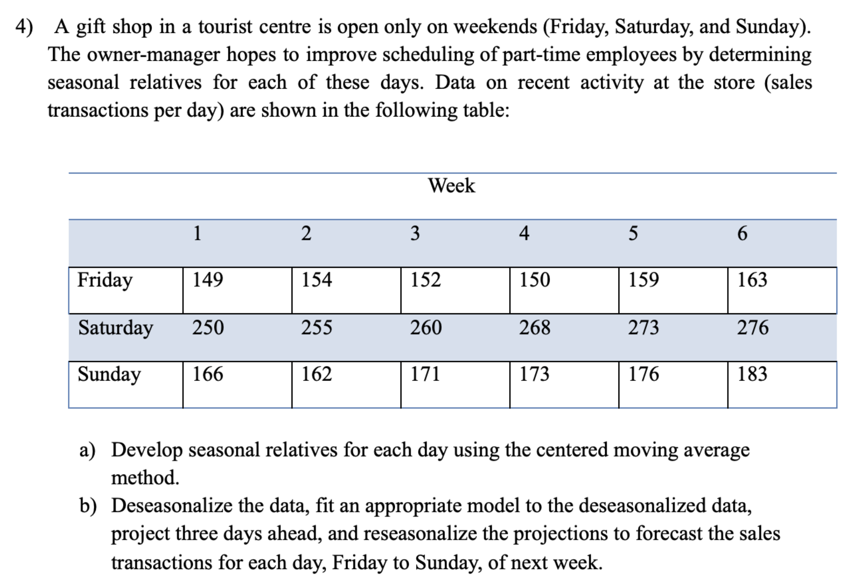

1. Seasonal relatives are shown as the values in the $adjusted$ row:

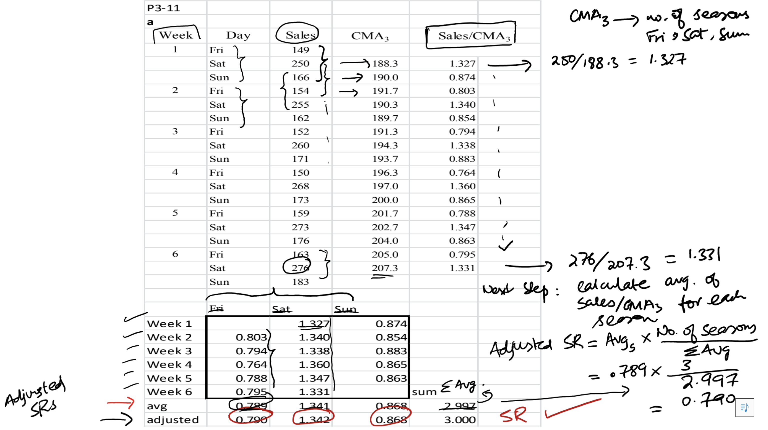

1. Deseasonalized data is shown as the values in the $Sales/SR$ column:

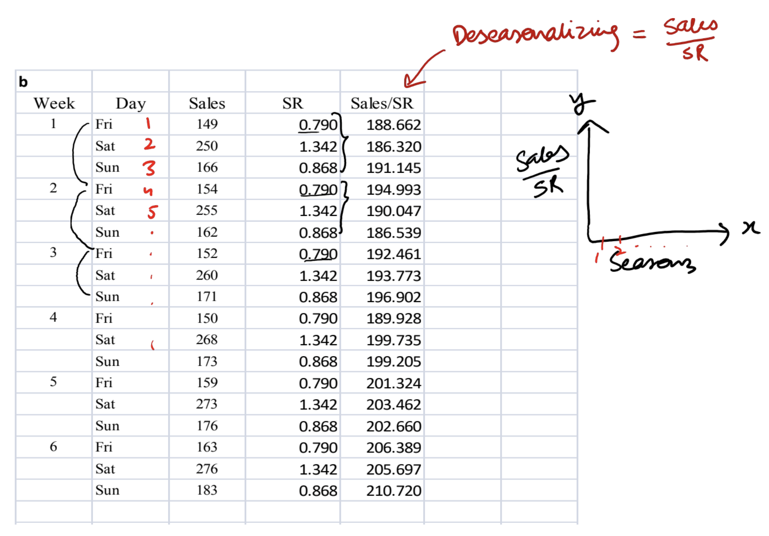

The model, projection, and reseasonalized data is shown below:

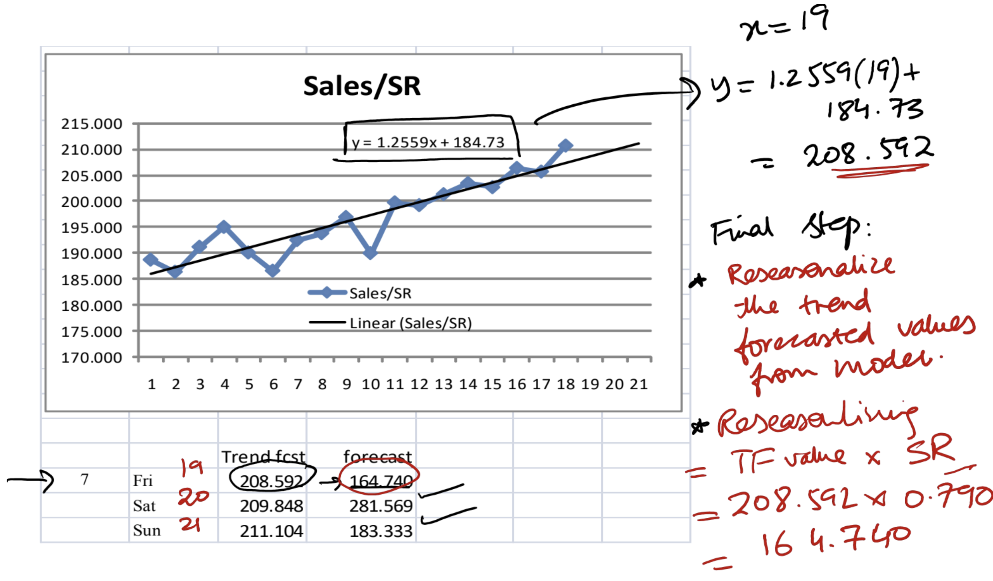

# Tutorial 2: Capacity Planning and Facility Layout

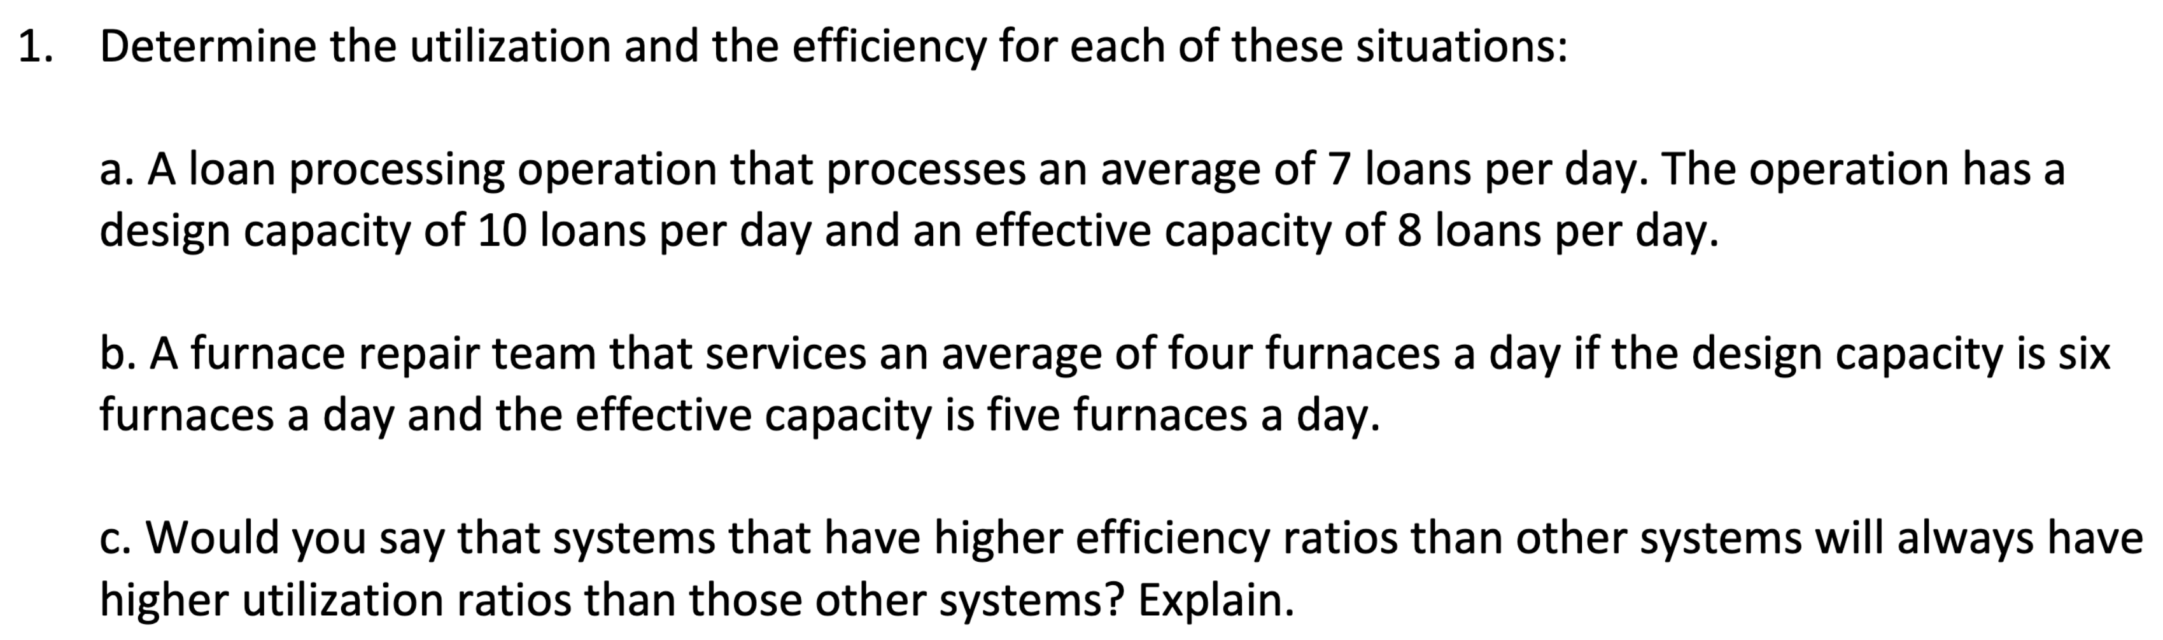

$actual output=7, design capacity=10, effective capacity=8$ $$utilization=\frac{actual output}{design capacity}=\frac{7}{10}=70\% \\ efficiency=\frac{actual output}{effective capacity}=\frac{7}{8}=87.5\%$$

$actual output=4, design capacity=6, effective capacity=5$ $$utilization=\frac{actual output}{design capacity}=\frac{4}{6}=66\% \\ efficiency=\frac{actual output}{effective capacity}=\frac{4}{5}=80\%$$

1. No because utilization depends on design capacity while efficiency depends on effective capacity.

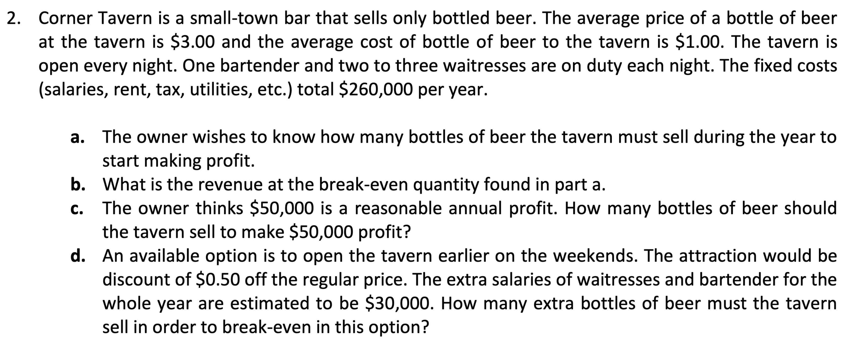

$average price=\$3.00, average cost=\$1.00, fixed cost=\$260,000$ $$Q_{BEP}=\frac{FC}{R-v}=\frac{260,000}{3-1}=130,000 bottles$$

$TR_{BEP}=Q_{BEP}⋅R=130,000⋅3=\$390,000$

$Q=\frac{P+FC}{R-v}=\frac{50,000+260,000}{3-1}=155,000 bottles$

$Q_{BEP}^{'}=\frac{FC^{'}}{R^{'}-v}=\frac{30,000}{2.5-1}=20,000 bottles$

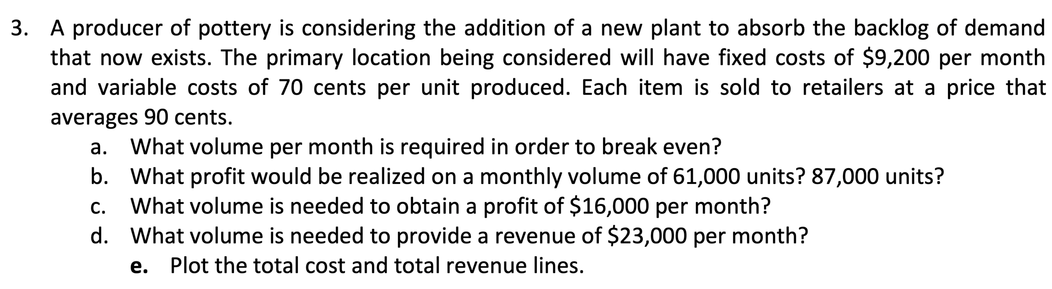

$FC=\$9,200, v=70 cents→\$0.7, R=90 cents=\$0.9$ $$Q_{BEP}=\frac{FC}{R-v}=\frac{9,200}{0.9-0.7}=46,000 units$$

$P=Q\left(R-v\right)-FC$ $$P_{1}=61,000\left(0.9-0.7\right)-9,200=\$3,000$$

$$P_{2}=87,000\left(0.9-0.7\right)-9,200=\$8,200$$

$Q=\frac{P+FC}{R-v}=\frac{16,000+9,200}{0.9-0.7}=126,000 units$

$Q=\frac{P+FC}{R-v}=\frac{23,000+9,200}{0.9-0.7}=161,000 units$

1. Plot of $total cost (TC)=0.7Q+10,000$ and $total revenue (TR)=0.9Q$ lines:

